SPORTS CLUB MANAGEMENT
@CREATIVITY THINK (9483175986/7019689991)

ABSTRACT:
Sports Club Management is a web application designed to streamline operations for sports clubs, fitness centers, and teams. Users can register, update profiles, join events, track fees, monitor performance, and view statistics through interactive dashboards. Administrators manage events, track performance reports, collect fees, manage message boards, and analyze analytics data. Built with Django and Django Rest Framework for backend services and React with Redux and Recharts for the frontend, the platform ensures efficient member management, transparent fee handling, and performance monitoring, facilitating effective club administration and enhanced member engagement..

INTRODUCTION OF THE PROJECT:
Managing sports club operations manually can be time-consuming and error-prone, especially when tracking memberships, training schedules, fees, and performance. Sports Club Management centralizes these processes on a web-based platform where members can register, join events, track fees, and monitor their performance, while administrators oversee events, manage fees, and analyze performance data. Utilizing Django for backend operations and React with Redux and Recharts for dynamic dashboards, the system provides a real-time, user-friendly, and efficient solution for sports club administration, enhancing operational productivity and member engagement..

PROJECT OBJECTIVES:

• Provide an online platform to manage sports club operations efficiently
• Enable members to register, update profiles, and join events
• Track membership fees and payment history
• Monitor and analyze member performance statistics
• Allow administrators to manage events and collect fees
• Generate analytics dashboards for performance and club management
• Improve communication through notifications and message boards

PROBLEM OF THE STATEMENT:
Sports clubs and fitness centers often face challenges in maintaining member records, tracking training schedules, managing fees, and monitoring performance manually. Lack of a centralized system leads to inefficient operations and poor member engagement. Sports Club Management addresses these issues by providing a web application that centralizes member management, event scheduling, fee tracking, performance monitoring, and communication. Administrators can oversee all operations and generate analytics, while members receive real-time updates and personalized dashboards, ensuring efficient and transparent club management..

MOTIVATION OF THE PROJECT:
• Centralize sports club operations in a single platform
• Streamline membership management and event registrations
• Facilitate fee tracking and payments
• Monitor and analyze member performance statistics
• Enhance communication and engagement via dashboards and notifications

BLOCK DAIGRAM OF PROJECT:

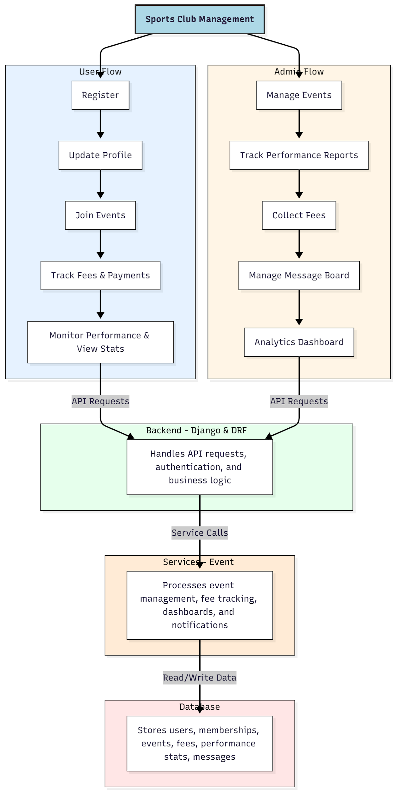

WORKING OF THE PROJECT:
Members register, update their profiles, join events, track fees and payments, and monitor performance statistics through dashboards. The backend handles authentication, API requests, and business logic. Services manage event scheduling, fee tracking, notifications, and analytics dashboards. Administrators manage events, track member performance reports, collect fees, oversee message boards, and generate analytics dashboards. This integrated system provides a centralized, real-time, and user-friendly solution for managing sports club operations, enhancing both administration efficiency and member engagement..

SOFTWARE REQUIREMENT:
- Backend:
  - Python 3.x
  - Django
  - Django REST Framework
  - SQLite/PostgreSQL
- Frontend:
  - Node.js and npm
  - React.js
  - Axios
- Development Tools:
  - Visual Studio Code
  - Postman (for testing APIs)
  - Git/GitHub (for version control)
- Server/Deployment (Optional):
  - Gunicorn, Nginx, or Heroku/AWS for hosting

ADVANTAGES OF THE PROJECT:

• Centralized sports club management
• Streamlined member registration and profile management
• Efficient event scheduling and fee tracking
• Monitor and analyze member performance
• Dashboard for administrators and members
• Real-time notifications and alerts
• Reduce manual effort and errors
• Enhance member engagement and club operations

APPLICATIONS OF THE PROJECT:
• Sports clubs and fitness centers
• Community and recreational teams
• Personal training programs
• Event and competition management
• Membership fee tracking and collection
• Performance monitoring and analytics
• Communication through message boards and notifications
• Administrative dashboards for operational management

REFERENCES:

- Django REST Framework Documentation — Django Software Foundation. Django Documentation. Available: https://docs.djangoproject.com/
- Django REST Framework. DRF Documentation. Available: https://www.django-rest-framework.org/
- React. React Official Documentation. Available: https://reactjs.org/docs/getting-started.html
- Redux. Redux Documentation. Available: https://redux.js.org/introduction/getting-started
- PostgreSQL Global Development Group. PostgreSQL Documentation. Available: https://www.postgresql.org/docs/
- MySQL. MySQL Reference Manual. Available: https://dev.mysql.com/doc/
- Git. Git Documentation. Available: https://git-scm.com/doc
- Node.js. Node.js Documentation. Available: https://nodejs.org/en/docs/
- Axios. Axios Documentation. Available: https://axios-http.com/docs/intro
- Socket.io Documentation – https://socket.io/docs/

